User Guide for GUI_ARCoatingSim_v1

Xin Wen

**Intro**

This program can generate the recipe of thin film coating by given transfer function or passband, based on MATLAB.

**Interface**

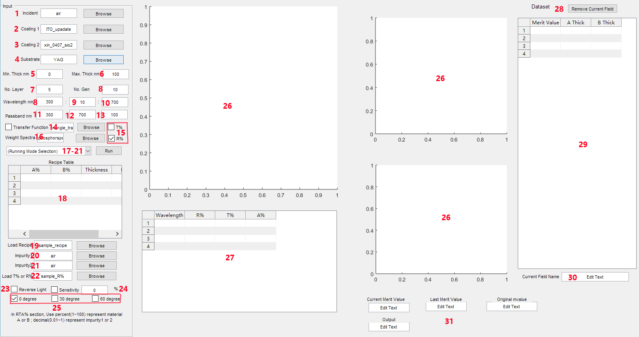

**Principle**

The principle of the program is using generation algorithm to find a recipe (coating structure) with best merit value for the system.

The system’s reflectivity, absorption, and transmittance is calculated by transfer-matrix [1].

The system’s structure is showed as following graph (default light, if click No.23 reverse light, direction of light and order of layer will be reversed). Material can be set in No.1-4, coating thickness range can be set in No.5-6, number of layer can be set in No.7, and number of generation can be set in No.8. In general, more generation can get better result, but also costs more time for simulation.

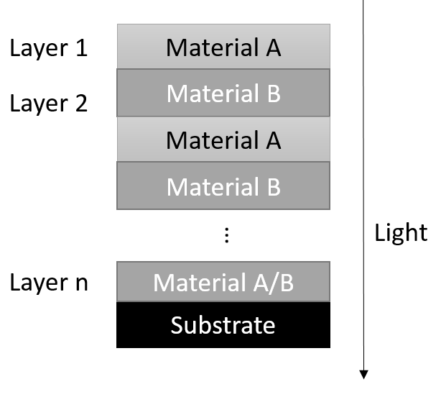

There are two case for calculating merit value: If TF (transfer function) is selected,

Merit_value= [|(TF-R%)|.*f]’*s

R% is calculated reflectivity for current system (If click T% instead of R% in No.15, R% will be replaced by 1-T%, so absorption will be considered); f is filter determined by No.11-13; s is weighted spectra determined by No.16. R%, TF, f and s are n*1 vector. If TF is not selected,

Merit_value= (R%.*f)’*s

Parameter is same to last equation.

As for the filter in No.11-13, No.11 is passband start point, No.12 is passband end point, and No. 13 is factor. Notice that the passband should be with in the range setted in No.8-10. No.8 is start wavelength, No.9 is scale, and No.10 is end wavelength. For example, if you set it as



You will get a filter in following shape:

You can change your prefrence of filter in file ‘filtergenerate.m’.

**Function**

1. No.17, weak simulation

* Setting

To run weak simulation, you need to set No.1-13, No.15, No.16, and choose some degree in No.25. If you want to use transfer function, click the checkbox in No.14 and select one. If you want to reverse light, click checkbox in No.23; If you want the coating to be less sensitive to thickness, click check box in No.24 and set a percentage. At last select weak simulation in dropbox and click run.

* Example1: Design an AR coating for phosphor (YAG:Ge), using material ITO and SiO2

Step1: Set the parameter as following.

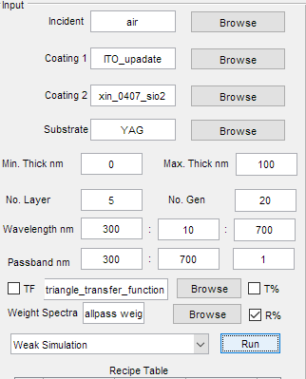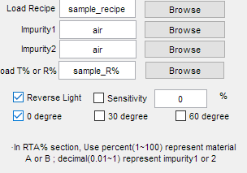

Step2: Click Run, check the information in command window.

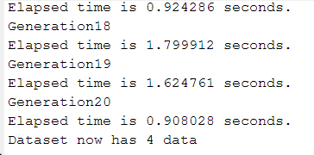

Step3: When finishing, recipe and R% graph will be presented. You can copy the data in table.

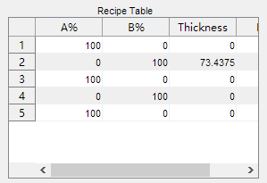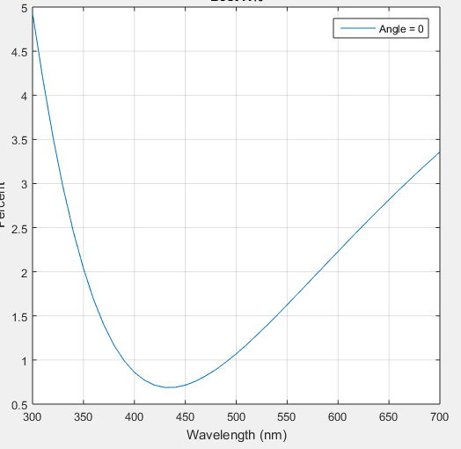

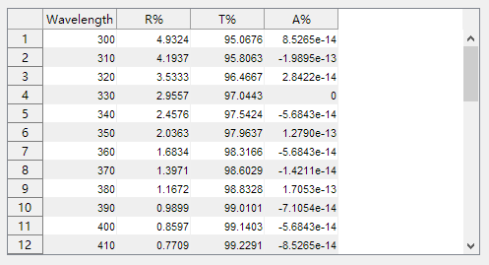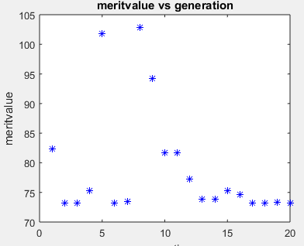

* Example2: Design a bluepass, yellow stop coating for glass.

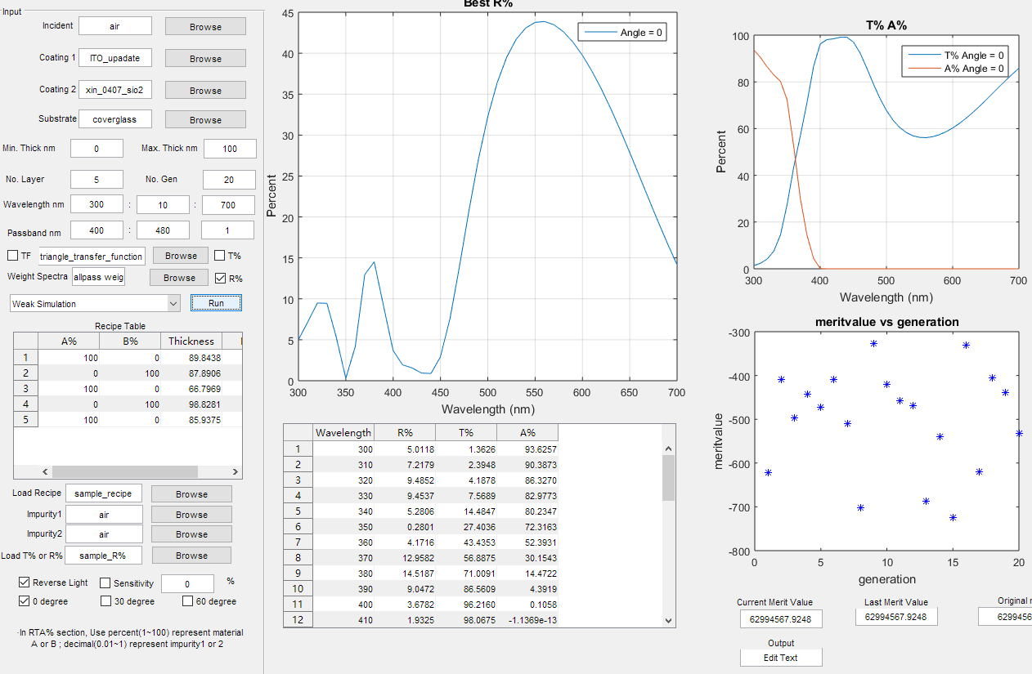

* Example3: Create a coating, the R% has a triangle shape

Step1: Create a txt file for triangle shape transfer function.

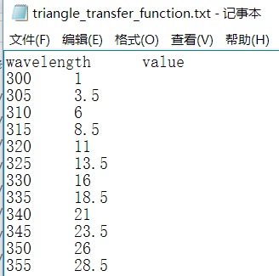

Step2: Select it in TF (No.14) and run it. You may not get the same curve due to limited thickness, layer, or the material itself.

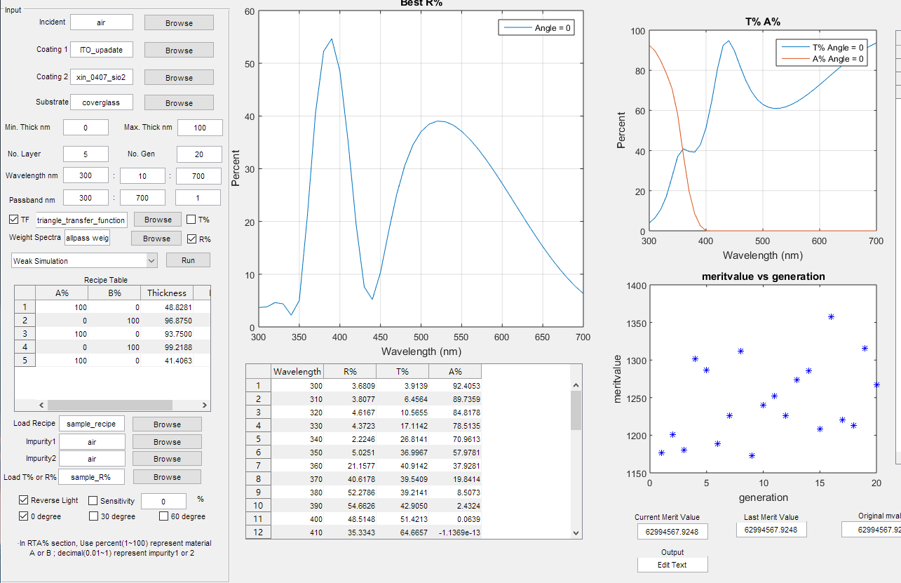

2. No.18, strong simulation

* In some case, you don’t know how many layer should be used for coating. So you can run 1 layer, 2 layer, …, 10 layer in weak simulation and then choose strong simulation and run it. The call back will be the best result in the previous weak simulation and the recipe will be listed in a table (No.29).
* Example4: Find a AR coating for phosphor (YAG:Ge), weighted by phosphorspectra.

Step1: Set No.layer to 2, run weak simulation.

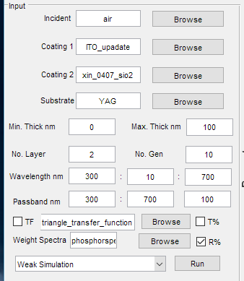

Step2: Set No.layer to 3, run weak simulation. Repeat it till No.layer is 6.

Step3: Select Strong Simulation and Run it. You can get the best result among previous simulation.

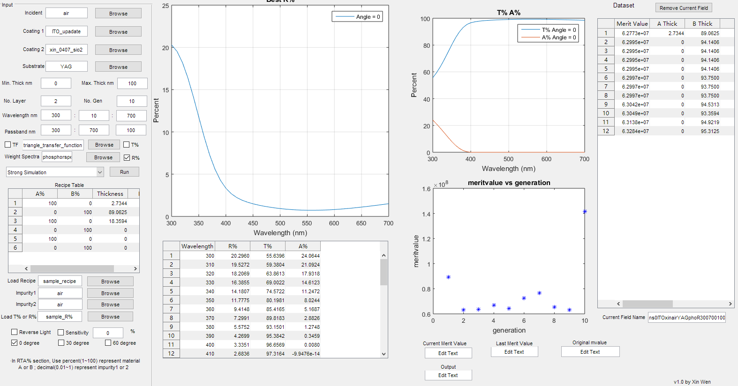

* Don’t set No. of layers more than 20. It won’t be collected by dataset.
* Boosting technique may be used, but the dataset is too small for that.

3. No.19, two layer plotting

* Setting: To run two layer plotting, you need to set No.1-4, No.6, No.8-13. The program will generate a 3D graph, x and y axis is thickness for coating 1 and coating 2, z axis is merit value
* Example 5: Simulate single layer SiO2 and ITO coating on phosphor, find the best recipe.

Step1: Select 2-Layer plotting in dropbox, click run, and graph will be generated in about 10 seconds.

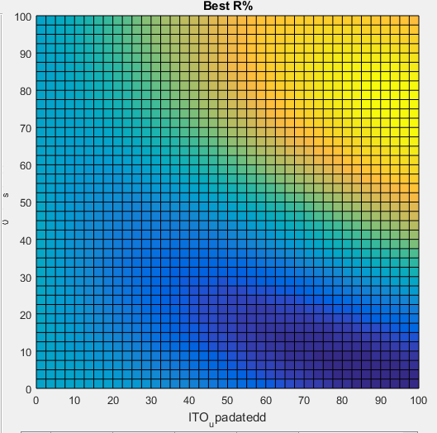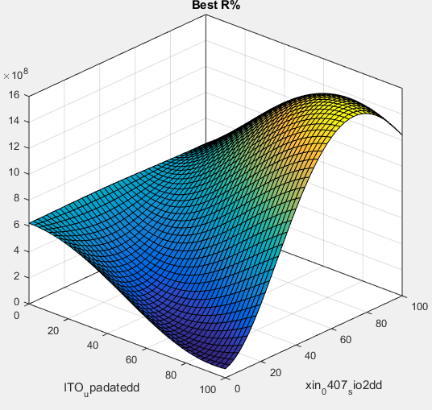

Step2: From above graph, best recipe should be around 90nm ITO, 0nm SiO2.

4. No.20, RTA% by recipe

* After using weak simulation/ strong simulation, or you already have a recipe and want to see its performance, you can use RTA% by recipe.
* Example 6: Load ‘Sample recipe.txt’, adjust the thickness and find a good recipe for AR coating.

Step1: Load sample recipe in No.19, select %RTA by recipe and run.

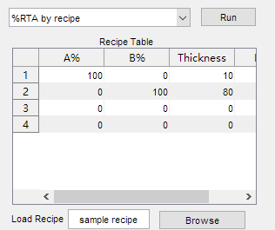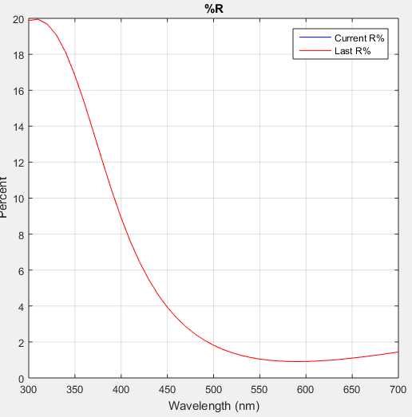

Step2: Adjust thickness and click run again, to see if the R% decreases. Merit value at No.31 may help you make the decition. A 3-D merit value graphing will also be plotted in some case.

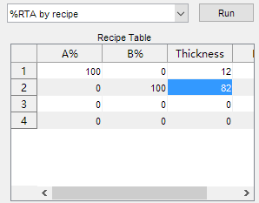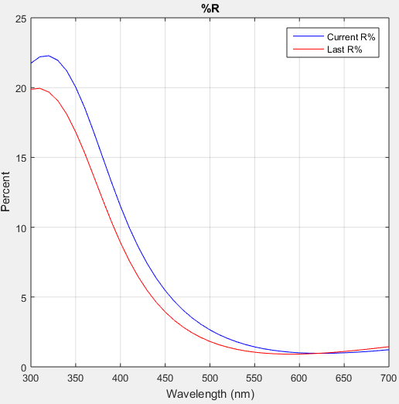



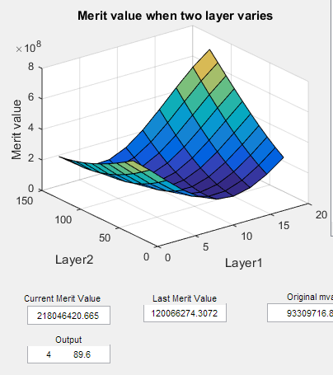

Step3: From the 3D graph, the output is 4 and 89.6, it means layer1 with thickness=4 and layer2 with thickness=89.6 is a relative good result. So change the thickness to 4 and 89.6 to see it again.

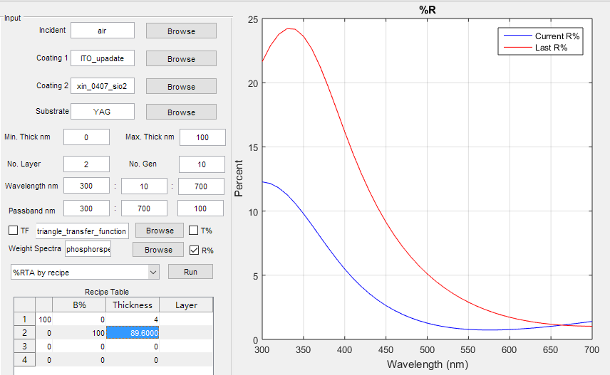

Step4: Adjust thickness, untill get a desired result.

Step5: In real coating, some dioxide and air may be revolved, you can add them in Recipe Table to see the performance. If you use number 1-100 in column A% and B%, the mateirial will be regarded as coating 1 and coating 2. If you use 0.01-1 in column A% and B%, the material will be regarded as impurity 1 and impurity2 selected in No.20 and No.21. The following graph is the performance with 1 nm air gap.

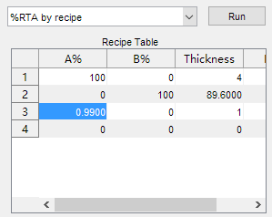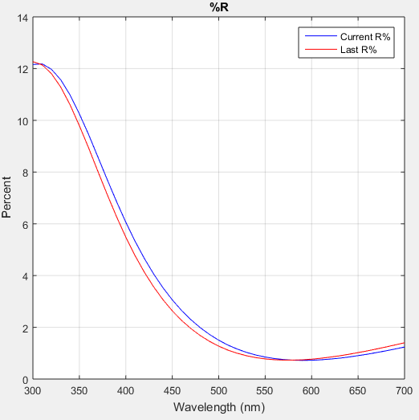

5. No.21 Load R% or T% data

* Some time you have a measured data by some device, and want to see the difference with simulation result, you can load it in this section, but still need to adjust it in %RTA by recipe.
* After loading, in %RTA by recipe section, the curve will always be there as background.

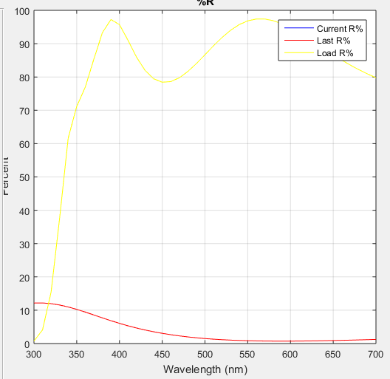

**Reference**

[1] M. Claudia Troparevsky, Adrian S. Sabau, Andrew R. Lupini, and Zhenyu Zhang, Transfer-matrix formalism for the calculation of optical response in multilayer systems: from coherent to incoherent interference, Optics Express Vol. 18, Issue 24, pp. 24715-24721 (2010).

[2] David Klotzkin, read_material_data.m, coading part.

[3] Generation Algorithm Tutoring, <http://blog.163.com/zhaoshuyu_thomas/blog/static/461929072009103034816716/>.

[4] MIT OpenCourseWare, Learning: Boosting, <https://www.youtube.com/watch?v=UHBmv7qCey4>.

[5] Petr Kužel, Layered structures: transfer matrix formalism. <http://www.fzu.cz/~kuzelp/Optics/Lecture6.pdf>.